Identify the fraction
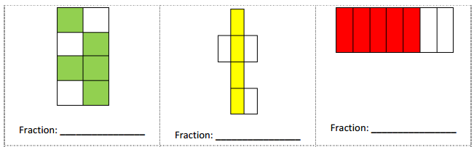

Marry make pizzas with two toppings, pepperoni and mushroom. Shaded parts are pepperonis and the rest are mushrooms. What fractions are pepperonis or mushrooms?
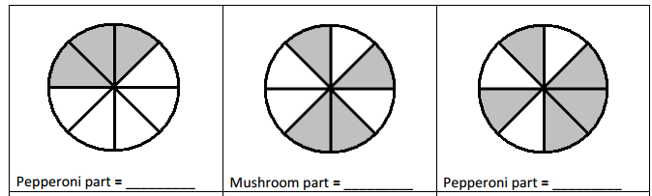

Identify the Whole Part and Fraction Part
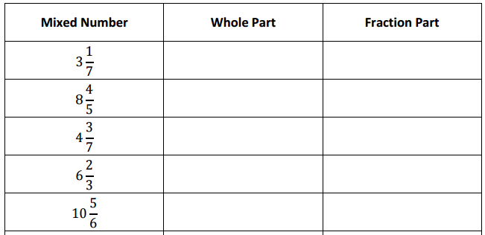

Reduce the Fractions to its Lowest Terms
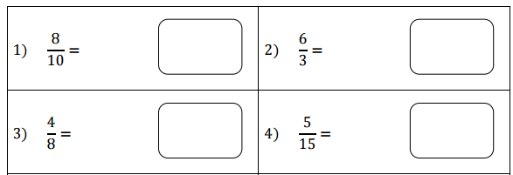
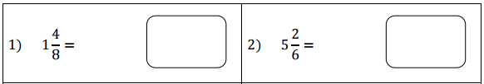

Addition & Subtraction of fractions
Proper Fraction:

Improper Fraction:

Mixed Fraction:
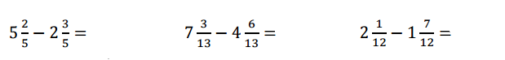
Unlike Fraction:

Fill in the missing numbers.
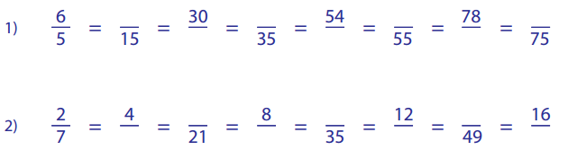

Convert Improper Fraction into Mixed Fraction
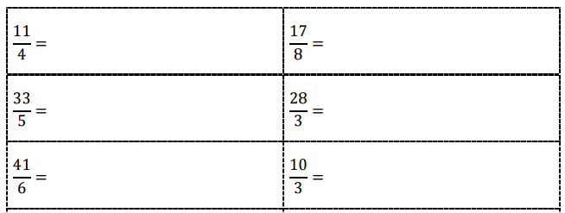

Convert Mixed Fraction into Improper Fraction
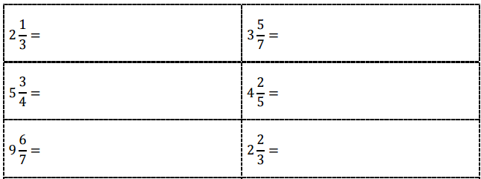

Multiply using Repeated Addition
Multiplication Without Cross Cancellation
Multiplication With Cross Cancellation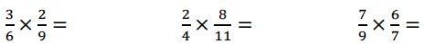

Convert mixed numbers into improper fractions, simplify the terms, find multiplication, and then convert the answer to mixed number where ever possible

Dividing Fractions

Write the ratio
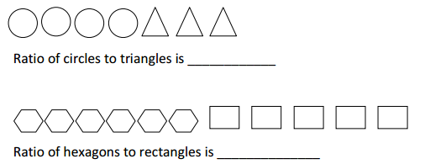

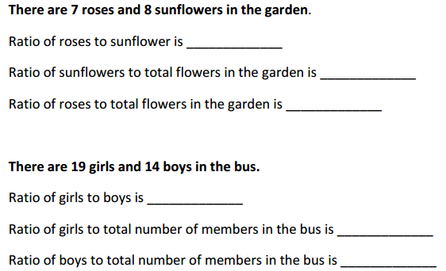

Write the Fractions as Ratio

Write the Ratios as Fraction

Compare the following ratios: (Use >, < or = sign in the place holders)

State whether the following ratios are proportional:

Solve for the unknown in the given proportions:

